Creativity or Conformity? Building Cultures of Creativity in Higher Education

A conference organised by the University of Wales Institute, Cardiff in collaboration with the Higher Education Academy

Cardiff January 8-10 2007

Enhancing creativity in Higher Design Education:

analogy as a tool for brainstorming

Lucia Rampino & Matteo O. Ingaramo

Dipartimento Indaco, Politecnico di Milano, Italy
e-mail lucia.rampino@polimi.it

Copyright © in each paper on this site is the property of the author(s). Permission is granted to reproduce copies of these works for purposes relevant to the above conference, provided that the author(s), source and copyright notice are included on each copy. For other uses, including extended quotation, please contact the author(s).

Enhancing creativity in Higher Design Education: analogy as a tool for brainstorming

Introduction

The purpose of this paper is to define the role of the analogy within the creative phase of the design process and to clarify in what way thinking by analogies can help design students to become more creative. The first part of the paper (paragraphs 1 and 2) is devoted to the definition of both the concepts of design and creativity. The aim is to define the role of creativity within the design process. In the second part (paragraphs 3 and 4), the paper focuses on the analogy as one of the tools that can be used for generating new ideas; this part is completed with examples of both successful products and students’ concepts designed thinking by analogies.

Design as a Process
To define what design is, is not quite banal; John Heskett affirms that: “Design […] as a word is common enough, but it is full of incongruities, has innumerable manifestations, and lacks boundaries that give clarity and definition” [11, p. 2]. Many are the definitions of design that underline its processual nature. Bürdek, for instance, states: "Every design object is to be understood as the result of an evolutionary process whose course is effected by different conditions and choices, not only creative." [13, p. 118]. Also in the field of Design Management, the definitions of design activity tend to underline its processual nature. Bettina Von Stamm [9, p.12] defines design as: “The decisional process through which information is transformed in a result”. The term design refers therefore to a process that always has a tangible result (outlines, sketches, prototypes, a product, a logo, a graphic interface, a service….).

The aim of the designer is to explore, to experiment, to compare alternative solutions in order to choose the best. The ability typical of the designer is to give both sense and form to new ideas.
The starting point of every design process is the existence of a problem to be resolved through a project. First of all, it is necessary to clearly identify the problem; once this is done, the designer follows a logical succession of steps. Typically, the design process has three main steps:
- Research
- Concept generation
- Concept development

According to the authors, it is important for design students to understand the processual nature of the design activity and to learn some tools for managing such a process. The design process is explained to students showing them the following chart, where the three main phases are illustrated:

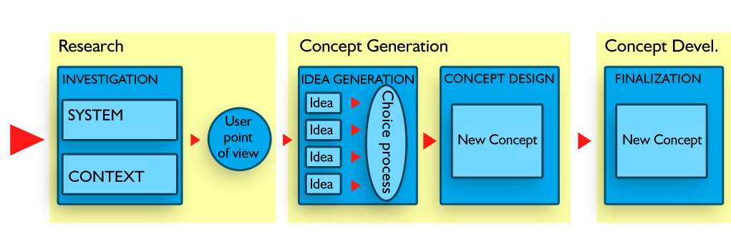
Figure 1. The design process
Gui Bonsiepe [1, p. 158] states that every design process has both a macro- and a micro-structure, where for “macro-structure” he intends the subdivision of the design process into different phases or steps, while for “micro-structure” he intends the description of the specific tools used in each of the phases. While all the studies related to the design methodology have allowed a broad clarification of the macro-structure of the design process, less attention has been devoted to the study of its micro-structure. It is only on the micro-structure of the design process that this paper is focused.

Creativity and the creative process
Creativity can be defined as the ability to generate new ideas. Taken in this sense, it is the starting point of every process that aims at reaching innovation. Given that innovation is of great importance for all companies that want to stay competitive in the market, it is easy to understand why creativity, as the main source of innovation, has in recent years gained so much attention. In contrast, in the past, the scientific community refrained from investigating the issue of creativity. The philosopher Karl Popper expressed in a clear way the assumption hidden behind this reticence: "Creativity is a divine spark that may not be dismantled and examined by use of scientific tools." [16, p. 31]. It is therefore hardly surprising that until the seventies no in-depth investigation was conducted on creativity.

The study of both the creative thought and the methods to favour it remained for several years the domain of professionals that regularly had to face problem-solving activities. In this way, many methods for creativity appeared and spread; their lowest common denominator was the idea that in order to light the creative spark, all that was needed was to give up the frame of the traditional way of thinking and to diligently look for a non-conventional structure allowing the suspension of judgment and criticism.

The pioneers that violated the academic taboo preventing the scientific research in this field were the cognitive psychologists, soon followed by the neuropsychiatrists, the researchers on artificial intelligence, the engineers and, lately, the marketing experts [16]. Today, the consensus is that creativity can be stimulated by learning and supported by the creation of the right environment and atmosphere; moreover, creativity is thought to be a process that is possible to direct and to sustain using a series of tools. Before focussing our attention on one of such tools, namely the analogy, the moment has come for asking the following question: how does a creative process work?
Hermann Helmholtz, a German physicist, was one of the first, in the XIX century, to try to describe the creative process as a succession of steps, which he defined: saturation, incubation and illumination.

The French mathematician Jules Henri Poincare, in 1908, added a fourth phase, the final check of the identified solution [15]. In more recent times, on the base of a comparison among various models of the creative process, Paul E. Plesk [2] reached the following conclusions:
- The creative process involves purposeful analysis, imaginative idea generation and critical evaluation – the total creative process is a balance of imagination and analysis.
- While older models tend to imply that the creative idea results from subconscious processes, largely outside the control of the thinker, modern models tend to imply purposeful generation of new ideas, under the direct control of the thinker.
- The total creative process requires a drive to action and the implementation of ideas.

We welcome from Plesk the idea that the main phases of every creative process are three:
- the initial analysis (that corresponds to the research phase in the design process)
- the generation of new ideas (present also in the design process)
- the critical evaluation of the generated ideas (that corresponds to the choice process in the design process)

It follows that, in every design process, it is possible to recognize a creative phase, which is aimed at generating new ideas [2]: this is what makes the design activity so proper to produce innovation.

Creative Phase

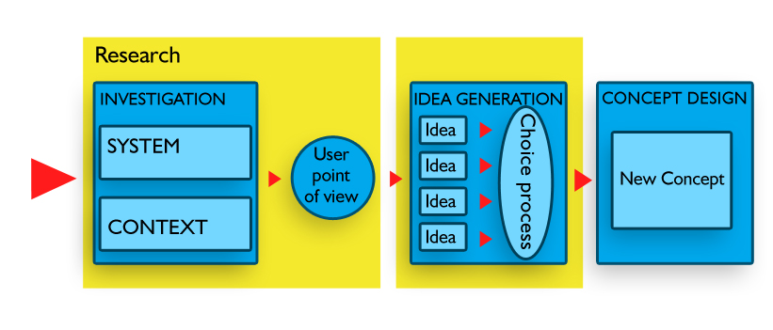

Figure 2. The creative phase of the design process
One of the main worry of the firms that desire to become more innovative

Figure 2. The creative phase of the design process

One of the main worries of firms that desire to become more innovative is therefore how to become more creative, that is to say how to produce more and better ideas. For this reason, some companies have developed a series of tools to manage the creative process. Such tools can be grouped into the following categories:
- tools for gathering and organizing research data
- tools for managing the ideas generation process
- tools for evaluating results.

In the following chart, the three moments of the creative process in which such tools are used are visualized.
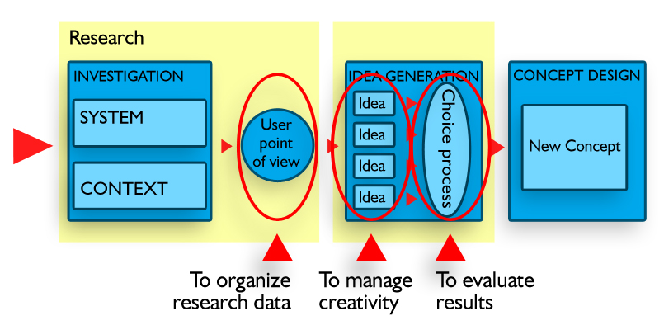
Figure 3. Tools for managing the creative phase
In the following part of the paper, we focus on the analogy as one of the most effective tools to be used for improving the designer’s skill at generating new product ideas.

The analogy as a tool for enhancing creativity
Some psychologists have noticed that the essential feature of creative thought is the ability to link, in a useful way, ideas that are usually far from each other. A possible way to do this is the association by similarity, that is to say the analogy. [12, pp. 49-50] An analogy is said to be a "relationship of similarity between some constitutive elements of two facts or objects, such to deduce a certain degree of similarity between the facts or the objects themselves." [3] It has to be stressed that an analogy is not a simple resemblance like that between a person and his/her portrait; the analogy implies the rational choice of both the elements to be compared and the conditions under which said elements - that can also be apparently dissimilar - have to be regarded as similar.

The study of the concept of analogy belongs to many fields of human knowledge: from philosophy to theology, from mathematics to science [6]. Holyoak and Thagard, two American psychologists, have defined in the following way the structure of the analogical way of thinking: “trying to reason and learn about a new situation (the target analog) by relating it to a more familiar situation (the source analog) that can be viewed as structurally parallel” [5]. It is now clear that the association by analogy is the result of rational thinking and concentrates on the similarities in structure and function between two things and, by this way, on what make them different. For this reason, the analogy helps us "to understand the unknown through the known and to overcome the gap that separates the image from the logical model" [8, p. 109]. The use of such a tool belongs to the history of design: a brief note on the use of the analogy can be found in Bonsiepe’s “Teoria e pratica del Disegno Industriale” (Industrial Design Theory and Practice) [1].

The use of the analogy seems to be particularly inherent in the Japanese design culture. In the book The Knowledge-Creating Company by Nonaka and Takeuchi [8], is presented the case of the development of an innovative Japanese product: the Honda City. Such cases demonstrate the way Japanese managers tend to use figurative language to develop new products: such language can assume the form of both the metaphor and the analogy. The analogy, compared to the metaphor, is better in setting a structured distinction between two ideas or objects, since it allows us to clarify the elements of similarity that link them and the elements that make them different. In this sense, the analogy constitutes "a conjunction between the pure imagination and logical thinking" [8, p. 40]. The use of the analogy being peculiar to Japanese design culture is well shown, for instance, by the work of the well-known designer Naoto Fukasawa: many of his products are designed starting from an analogy, as in the following two examples.

The design of the CD player manufactured by Muji comprises a wall-mounted box resembling a ventilation fan, with the CD spinning in the open air and operated, just like a fan, by a simple pull-cord. The analogy came to Fukasawa mind thinking about the similar spinning actions of both a CD player and a fan: he thought to convert this idea by starting the CD with a pull-cord as an ordinary ventilation fan. This unexpected meeting of the new and the familiar explains both the charm of the product and the fact that users find it approachable and can immediately grasp how to operate it [14]. Using Holyoak and Thagard terminology, we can say that in this case, the fan is the source analog, while the CD player is the target analog.

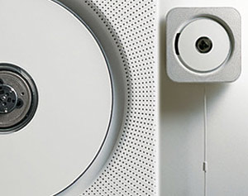
Figure 4. Source and target analog for Muji CD Player

Another example of thinking by analogy, drawn by the work of ±0 (the design firm founded by Fukasawa), is the Sole bag. In this case, the problem to resolve was the fact that many people are not happy with the idea of putting their bags on the ground. Thus, the target analog was a bag that people would not be worried about placing on the ground; obviously enough, the source analogs were shoe soles, more precisely, the rubber-soled shoes that are worn in schools throughout Japan. The color of the familiar rubber part of the shoe forms a focal point for the new bag.


Figure 5. Source and target analog for ±0 Sole Bag

Unlike Japan, western culture is historically hostile to the use of the analogy, which has never directly entered into any scientific theory, despite the fact that it has always accompanied, but from the outside, the progress of the scientific knowledge. And this because western science, based on the Galilean method, is "mathematised". And in mathematics, as it has developed so far, to each symbol must correspond one and just one definition. Accordingly, also where there is no use of mathematics, western logical thinking has adopted the principle of univocality as the only guarantee of avoiding any possible risk of ambiguity, and therefore of error. It is, however, interesting to note that, in the last decades, the researches on the issue of complexity in the different fields of science seem to show the limits intrinsic to the concept of univocality and to propose, instead, an analogical kind of approach [4].

Even if, officially, the analogy has never been an integral part of any scientific theory; nevertheless, it is often employed by scientists in the qualitative description of their results. In more detail, in the history of sciences, analogies have shown themselves useful with a double function [4]:
- to suggest, during the research phase, a way to build a theory
- to provide help to interpret an already built theory, in similarity to another theory that has the same structure.

In the same way, in the design field, and in particular in generating new ideas, it is possible to distinguish two kinds of analogy:
- the analogy to create, that is using analogical references to build the functions and the efficiency of a product
- the analogy to communicate, that is using the analogy to set a designed vision able to be interpreted by clients and consumers.

Both, as will be illustrated hereafter, can add value to the design activity.

3.1 The analogy to create

As demonstrated by the work of Fukaswa and his collaborators, in the "Concept Generation" phase of the design process, phase in which it is necessary to develop many product ideas, thinking by analogies is an effective tool to widen one's reasoning. In order to investigate the analogies, students are asked as first thing to carry out a wide research activity. In fact, any creative process, even when it seems coincidental, is based on a deep knowledge of the issues faced and is always an extension of what is already known: a thorough analysis phase is therefore fundamental [12].What we ask students to do is to identify and to analyse all the existing solutions in the sector of the product to innovate and in other analogous sectors in relation to:
- Materials and technologies
- Functions and directions of use.

It is therefore possible to distinguish two types of analogy:
- Technological
- Functional and of use.

The technological analogy can be described as the transfer of technologies, techniques and materials between two different industrial sectors. Such transfer consists in the passage between the two sectors of a flow of knowledge related to technologies and materials. The transfer often results in a simple acceptance from the least developed sectors of technologies and materials developed by the so-called "advanced technology" sectors: in this case, we talk about a simple technological transfer. In other cases, the analogical procedure becomes the real engine of a technological innovation.

For better illustrating the concept to students, a series of examples are used, some of which are reported hereafter.

A good example of technological transfer is the lamp Berenice designed by Meda and Rizzato and manufactured by Luceplan: it uses halogen low-voltage and high-efficiency light bulbs, developed in the auto sector for the car lights.
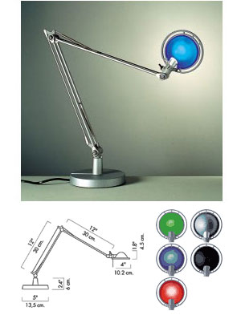

Figure 6. Technology transfer from the car to the lighting sector

A very good, and well known, example of technological innovation inspired by an analogy is the case of the Mini-Copier printer by Canon, reported by Nonaka and Takeuchi in their book [8, p. 107]. The objective of Canon was to produce a low-cost printer for personal and domestic use.
The more difficult problem to solve was finding a solution to produce at a reasonable cost a “replaceable all-in-one cartridge” that would eliminate the need for maintenance of traditional printers. The solution arrived thanks to an analogical cue taken from a can of beer (source analog): the project team focused on the possibility to apply the manufacturing process of beer cans to the production of drum cylinder using the same material, the aluminium.

The clearing up of both the analogies and differences in manufacturing led to the definition of a new process technology for manufacturing aluminium drum cylinders at a reduced cost; as a consequence, the possibility of developing a disposable all-in-one cartridge become real.
Today Canon keeps manufacturing “all-in-one cartridges” that contain all the essential print elements that wear out with use: toner and drum. In this way, changing the cartridge, the copier is, in the company’s words: “virtually as good as new”.


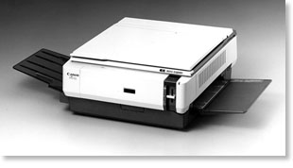

Figure 7. Source analog for the manufacturing process of Canon Mini-Copier cartridge


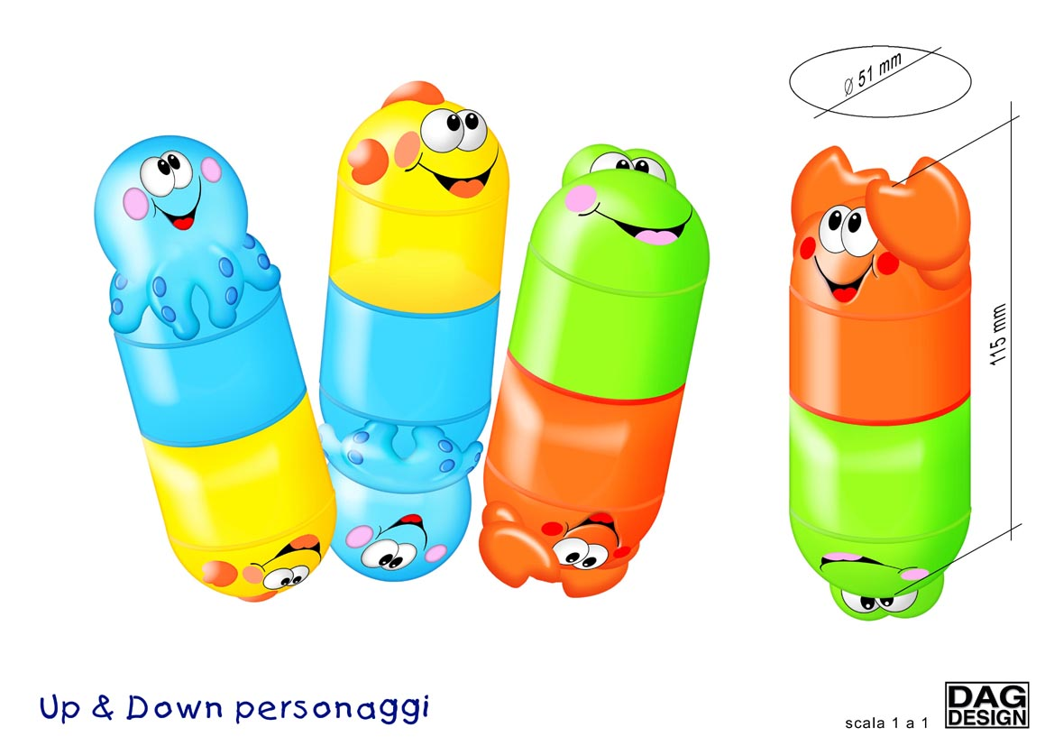
The product ”Gli amici sottosopra” (“The upside-down friends”) by Chicco represents a very intuitional example of functional analogy. The company designers were asked to design a new product for make babies playing during bath: the source analog that came to their minds was the float of the fishing hook. They created therefore a product that, immersed in water, behaved in the same way.

Figure 8. Source and target analog for Chicco “Gli amici sottosopra”

These and other examples, showed to students, help them to understand the effectiveness of the analogy as a tool to exercise the profession of the designer, a profession that is more and more asked to give a high creative contribution to the development of new products.

3.2 The analogy to communicate

The analogy is important to create new ideas, but is equally important to effectively communicate them. In fact, the result of every design process, be it a concept, a prototype, a product, a logo, a graphic interface, or a service, has to be easily communicable both to the client company and to the end user. For designers, to communicate their own new idea, it can be useful to make analogical references to what the company and/or the consumer already knows. The more innovative the product, and therefore the more difficult to communicate, the more valuable is the use of analogy.

We want to make our students think about the following: in order to communicate effectively how to use an innovative product, it is often worth using a strong analogical reference to what the consumer already knows. This is a simple way to make the new product easily comprehensible to the end user: Fukasawa CD player for Muji is a very good example of that. The analogy that the designer uses for communicating their product can either be the same as that used during the creative phase or can be identified only when the project has already been developed.

The communicative value of the analogy emerges also during the creative phase: in fact, the use of an appropriate analogy can be a very effective way to facilitate the involvement of more people in the creative process, above all if these people come from different contexts and have non- homogeneous working experiences. Such situation is that typical of multidisciplinary new product development teams, in which the designer has to learn how to interact effectively with engineers and marketing people [8]. Being able to use an appropriate analogy to express their own ideas, allows designers to effectively communicate contents, making the others gathering them in an intuitive way, without the need to resort to elaborate analysis strategies.

4. Examples
Hereafter are some practical examples of the use of the analogy drawn from the teaching experiences of the two authors.

Students: Andrea Oggioni, Pietro De Vecchi, Riccardo Colombo
Course: Design Workshop within an Industrial Design Master Course
Project: A new way to heat
Academic Year: 2004-2005

During a brief design Workshop lasting 3 days, the objective of this group of students was to design a small oven to quickly heat mono-portions and small quantities of food. Since the oven was not intended for cooking, reaching a maximum temperature of 120 degrees would have been enough.
Invited by the teacher to seek for all the possible ways to heat, the students picked out a suitable technological analogy in the sector of electric blankets, both for sporting competitions and domestic use. So, the students came to the idea of making their small oven as a sack that could be washed. From this idea, two questions arose. The first was related to the foods' fat that, in evaporating, would have impregnated the fabric; the second was the necessity to make all the electric connections water-resistant. Both of these problems have been faced and resolved by the students.




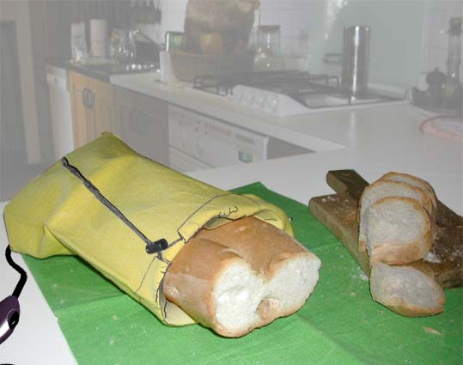

Figure 8. Technological analogies for creating the concept of sack domestic oven

Student: Andrea Mangone
Course: Bachelor Degree Thesis in Industrial Design
Project Title: Design of a Holter ECG
Academic Year: 2005-2006

The Holter is an appliance for the continuous recording of the electrocardiogram for a prolonged period of time, generally 24 hours. It consists of a small box that contains a recorder and a battery, to which 5 to 7 electrodes are connected; the electrodes are applied on the patient’s chest and uninterruptedly transmit to the recorder, through cables, the electric impulses produced by the heart.
The idea of the student was to insert retractable cables inside the Holter, so that to avoid the presence of long leaning cables on the patient chest. Instead of centralizing the retractable cables system in the recorder, the student decided to create a "chain" Holter and to position a retractable cable in every connector. This interesting solution generated the following problem to solve: that of blocking every cable in one direction (to prevent it from coiling back), allowing it to extend in the opposite direction, in order to follow the patient movements.

After careful analysis of different cable blocking systems, the student identified an already existing solution that seemed to best suiting the resolution of his own problem: the retractable cable used in some pc mouse. This system allows blocking the cable at different lengths, at a distance of around 8-10 cm. one from another, thanks to a series of curvilinear tracks on its base. This solution, clever but simple, was applied by the student to his project, getting the desired result: a Holter whose connectors have a retractable cable that allows us to block every cable at the necessary length (varying according to the dimensions of the patient chest), guaranteeing at the same time a further extension of 5 cm. to the cable, that is enough to allow the patient to move freely.
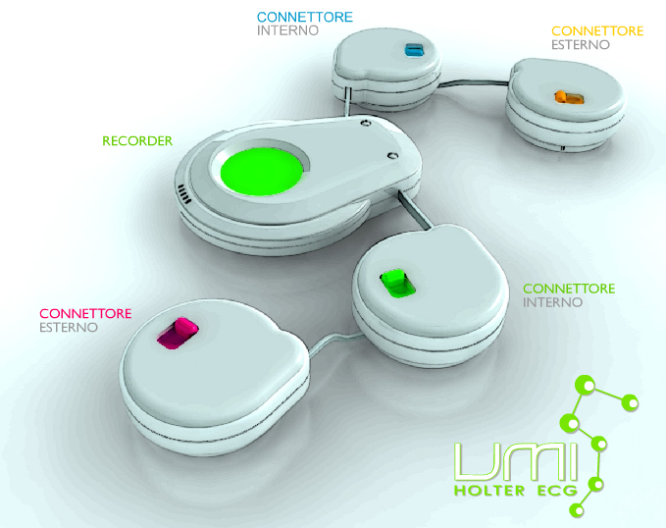

Figure 9. The “chain” Holter
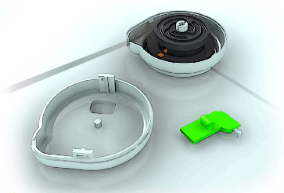
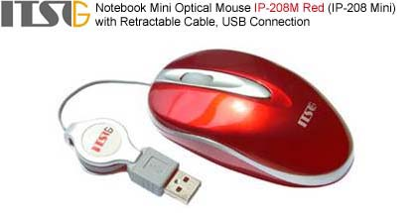

Figure 10. Source and target analog for the Holter retractable cables

Student: Federico Piccinini
Course: Bachelor Degree Thesis in Industrial Design
Project: TinO2: Design of an aerosol container of well-being
Academic Year: 2005-2006

In this project, the student's attention was not focused on the technological sphere, but on perception and interaction aspects: therefore, he chose an analogy of use with a high communicative value.
The student aimed at improving the capacity of the aerosol to communicate its own mode of use: to do this, the most natural way of proceeding is, as already said, to utilize an analogical reference to familiar forms and uses. Therefore, the student took inspiration from a very simple and familiar object: a kitchen glass pot. Just as pots, also TinO2 has a lid to unscrew: this is the upper part, in which the student has integrated the mouthpiece and the glass ampulla. The result is a product with a strong formal identity and an improved facility of use.




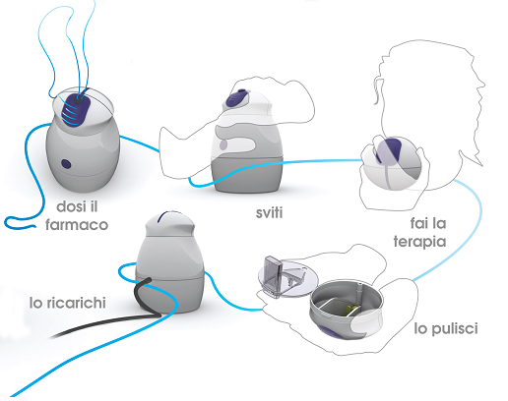
Figure 11. Source and target analog for TinO2

Figure 13. Mode of use of TinO2

References

[1] Bonsiepe, G., (1993), Teoria e pratica del disegno industriale, Feltrinelli, Milano
[2] Plsek Paul E. (1996),”Working Paper: Models for the Creative Process”, webpage (http://www.directedcreativity.com/pages/WPModels.html) [accessed 11 October 2004]
[3] G. Devoto, G.C. Oli, Il dizionario della lingua italiana, Firenze 1990
[4] Strumia, A., “Analogia”, http://www.disf.org/voci/29.asp, [accessed 16 November 2005]
[5] Holyoak, K.J., and Thagard, P. (1995). Mental Leaps: Analogy in Creative Thought. Cambridge, MA, MIT Press, ISBN 0262581442.
[6] Holyoak, K.J., and Thagard, P. (1997). The Analogical Mind, http://cogsci.uwaterloo.ca/Articles/Pages/Analog.Mind.html, [accessed 01 July 2006]
[7] Wikipedia contributors, 'Analogy', Wikipedia, The Free Encyclopedia, 8 July 2006, 08:09 UTC, <http://en.wikipedia.org/w/index.php?title=Analogy&oldid=62695556> [accessed 11 July 2006]
[8] Nonaka, I., Takeuchi, H., The knowledge creating company, Oxford University Press, 1995
[9] Von Stamm, B., (2003), Managing Innovation, Design and Creativity, Chichester, Wiley
[10] Walsh, V., Roy, R., Bruce, M., Potter, S., (1992), Winning by Design, Blacwell, Basil
[11] Heskett, John (2002), Design. A very short introduction, Oxford, Oxford University Press
[12] Rubini, V., (1996), La creatività, Giunti, Firenze
[13] Bürdek, B. E., (1992), Design. Storia, teoria e prassi del disegno industriale, Arnoldo Mondadori Editore, Milano
[14] Creativity Works 2003, How Muji used creativity to explore new brand building directions, D&AD (Brithis Design & Art Direction)
[15] Creative process. From Hermann Helmholtz to Jacob Getzels, in http://innovation.im-boot.org/modules [accessed 11 October 2004]
[16] Goldenberg, J., Mazursky, D., (2002), Creativity in product innovation, Cambridge University Press

